The Jira web installation interface should be presented.

Select the option: I will set it up myself

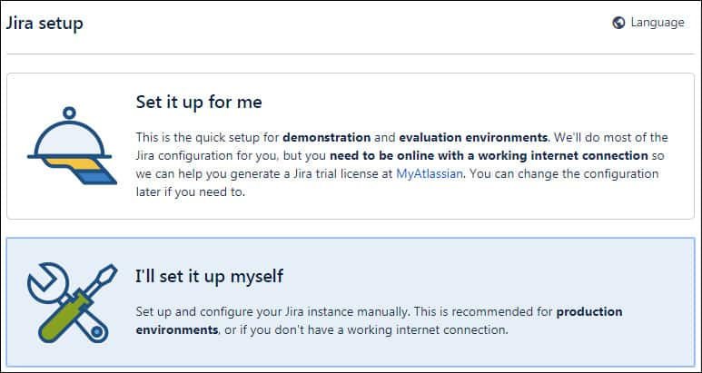
Click on the Next button.

Enter the Database information required to connect to the Jira database.
• Database Type: MySQl 5.7+
• Hostname: localhost
• Port: 3306
• Database: jira
• Username: jira
• Password: password123
Click on the Test Connection button.
After a successful test, click on the Next button

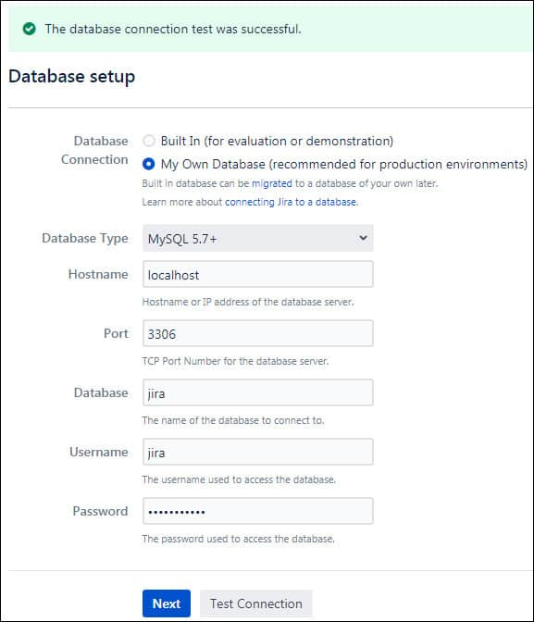
Wait while the Jira database is set up.
Set the Aplication name, the desired URL and click on the Next button.
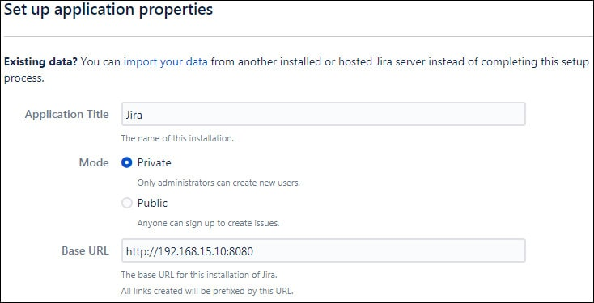
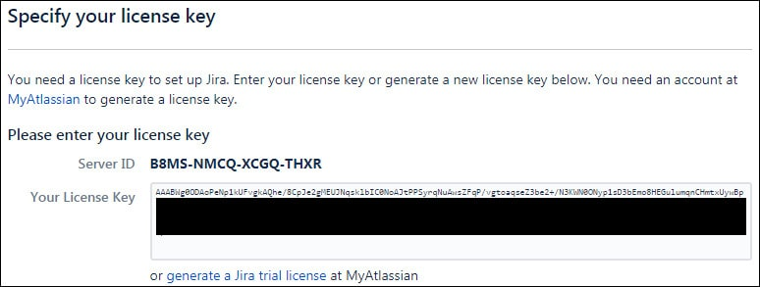
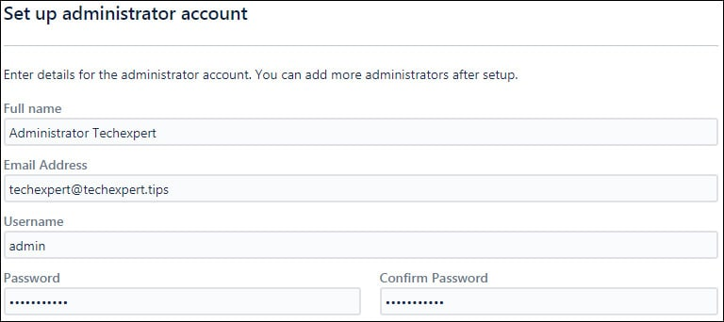
Set an administrator account.

Select the later option and click on the Next button.
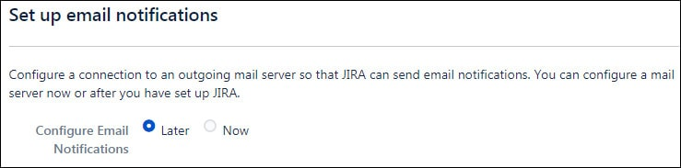
Select the desired language for the Jira web interface.
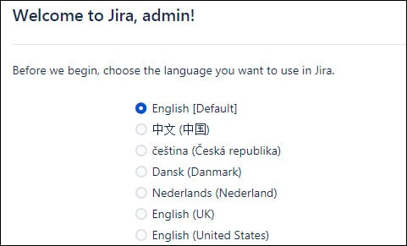
Set an avatar to identify yourself.
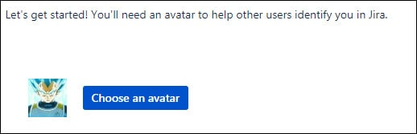
You will be sent to the Jira Dashboard.
